AUSTO AUTOMOBILE BUSINESS REPORT

UNDERSTANDING THE BUSINESS CASE:
Austo motor company is a leading car manufacturing company specialized in manufacturing suv, sedan and hatchback models. They want to understand the marketing performance of these models with respect to various attributes in their sales data. To understand the deeper insights of customers and their purchase preferences, we as a data scientist are expected to analyse the data and extract the valuable insights from it. These insights should help marketing team in understanding which variables or factors are affecting the sales performances and accordingly focus on the said approaches to attain desired results.

VARIABLES AND DESCRIPTION
SNO | VARIABLES | DESCRIPTION
1. | Age (in yr) | Age of the customer
2. | Gender | Male or Female (Binary variable)
3. | Profession | The Job of the customer (Binary variable)
4. | Marital status | Married and single (Binary variable)
5. | Education | Graduate and Post Graduate (Binary variable)
6. | No of Dependents | The No of dependents which include children, elderly parents etc
7. | Personal loan | "Yes" or "No" (Binary variable)
8. | House loan | "Yes" or "No" (Binary variable)
9. | Partner working | "Yes" or "No" (Binary variable)
10. | Salary | The customer's salary or income.
11. | Partner salary | The salary or income the customer’s partner
12. | Total salary | The added salary of the customer and their partner
13. | Price | The price of the car
14. | Make | The type of automobile - SUV, Sedan, Hatchback

MODULES DEVELOPED:

Python libraries used | Environment
Numpy, Pandas, Matplotlib, Seaborn | Google colab

DATA CLEANING:
- I cleaned the data by imputing the missing values with zeroes
- I removed the outliers by using the IQR method. IQR method helps in removing the outliers by imputing the Q3 range values to the above outliers and Q1 range values to the below outliers.
- I have also replaced the misspelled words like Femle, Femal from Gender column so that data is shown correctly.
DATA OVERVIEW:
- Using methods like data.head() , data.tail(), data.shape functions to understand the metrics and spread of the data

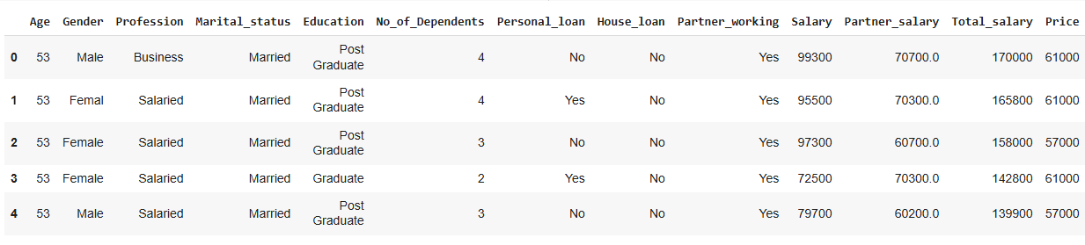
Image above: data.head() – First five rows of the data

DATA SHAPE
1581 rows and 14 columns

DATA ANALYSIS:

- Statistical analysis: Using a describe function to understand the summary of the data including the min, max, mean, standard deviation and quartiles, count, unique, top values and frequently appearing values.
- Treating outliers:
  - Defining the Q1 and Q3 to address the Interquartile range.
IQR = Q3 - Q1 # Defining the interquartile range
  - This helps define the outliers and impute the nearest lower bound and upper bound values to them.
  - This helps in bringing the outliers within the data range so that they do not affect the other datapoints.

Before treating a data:
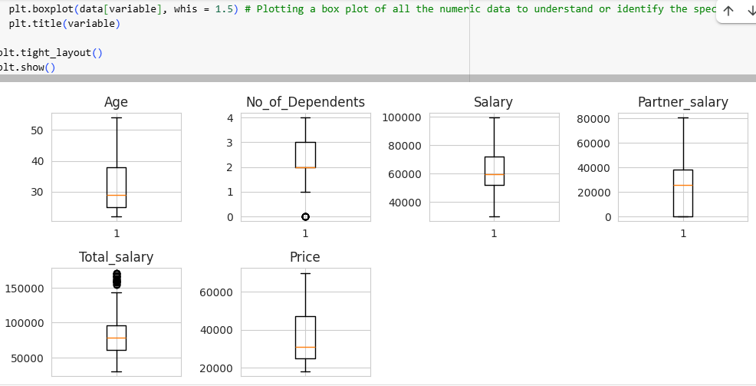

After treating outliers:
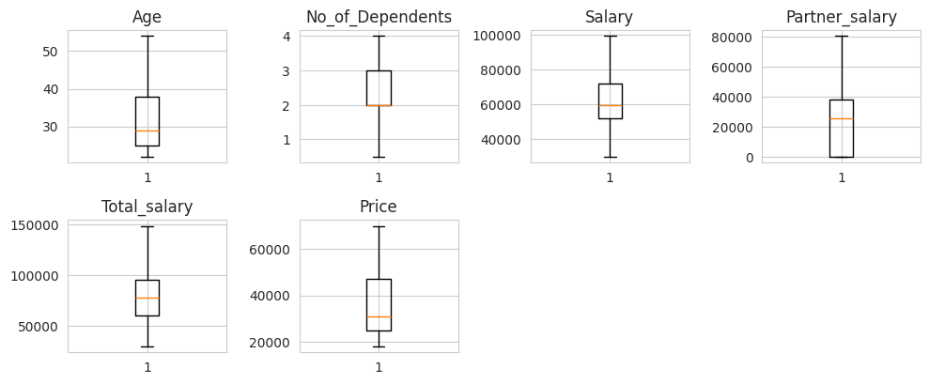

- Visualizations used:
- Box plot – Box plot helps check the outliers
- Scatter plot – Used to understand relationships and outliers of the data
- Histplot – Helps in visualising the distribution of variables
- Kdeplot – Kernel density estimation plot explains the density of data distribution for a variable
- Heatmap – Explain the correlation between multiple numerical variables
- Pairplot – combination of histogram and scatterplots used to understand the trends and correlation of the numeric variables
- Countplot – Used to visualize the categorical data
- Facetgrid - creating multiple plots by using subsets
- Jointplot - shows the relationship between two variables thus combining scatterplot and line graph on the same graph.
- Relplot – Relation plot between both categorical and numeric data
- Lmplot – Scatterplot with a regression line and a confidence interval.

Understanding and visualizing single numerical variable: Age

- The histogram shows the plot of age of customers and the count of distribution of data with the customers belong to the age group of 25-30 years.
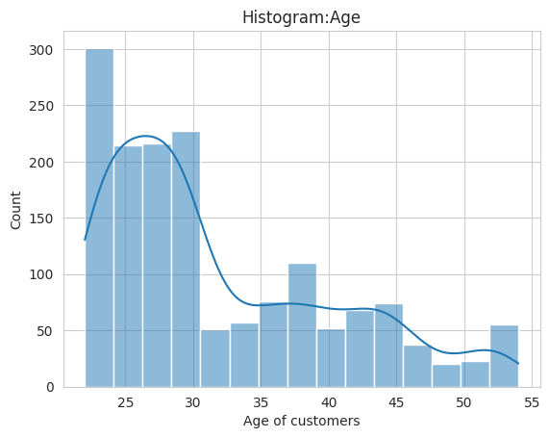

Understanding and visualizing single numerical variable: Total salary
- The box plot explains the total salary distribution with the count.
- This plot explains the median is closer to Q1 which explains most of the customers are having salaries less than median.

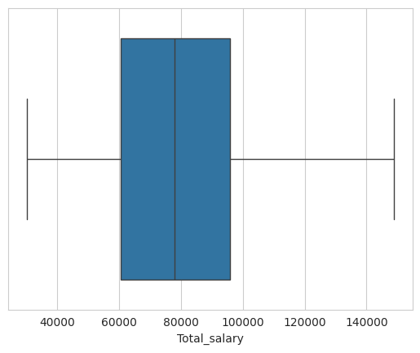

Understanding and visualizing single numerical variable: Price
- The said KDE plot - kernel density estimation, explains that the data is right skewed and probability density distribution of the price.
- Area under the curve indicates the density of these prices in different ranges.
- Data has two clusters indicating the distribution of price under two ranges which is 20000 to 30000 and 45000 to 55000.
- Most of the customers purchased the cars at around the median price of 20000 to 30000.

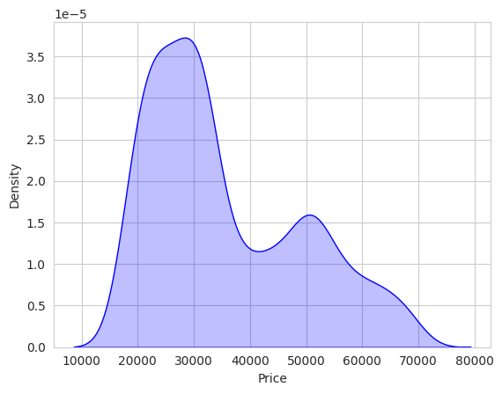

Understanding correlation between numerical variables using corr() function:
* This code calculates the correlation matrix for numerical data. A correlation matrix means understanding the correlation between all the numerical variables and how one variable affects the other.
* Values range from -1 to +1. When both variables show high values, its understood that they are strongly correlated. And if one variable show less values and the other shows higher values then weak correlation exist.

Key Takeaways
- Higher salaries seem positively correlated with purchasing higher-priced automobiles.
- Partner_salary contributes significantly to Total_salary with a 77% correlation.
- More dependents are leading to purchase lower-priced cars thus explaining a negative correlation effect.
- Age has a weak correlation with automobile price, suggesting spending is not heavily age-dependent.

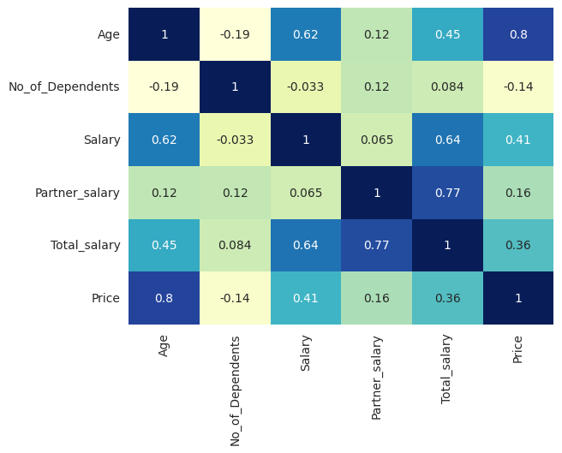
Heatmap visualizes relationships between variables in a matrix format.
- Salary and total salary show strong positive correlation as total salary is the sum of salary and partner salary
- Similarly partner salary correlate well with total salary
- No of dependents and price show negative correlation which means customers having more no of dependents tend to buy lesser priced cars
- Age and price show a zero or no correlation.

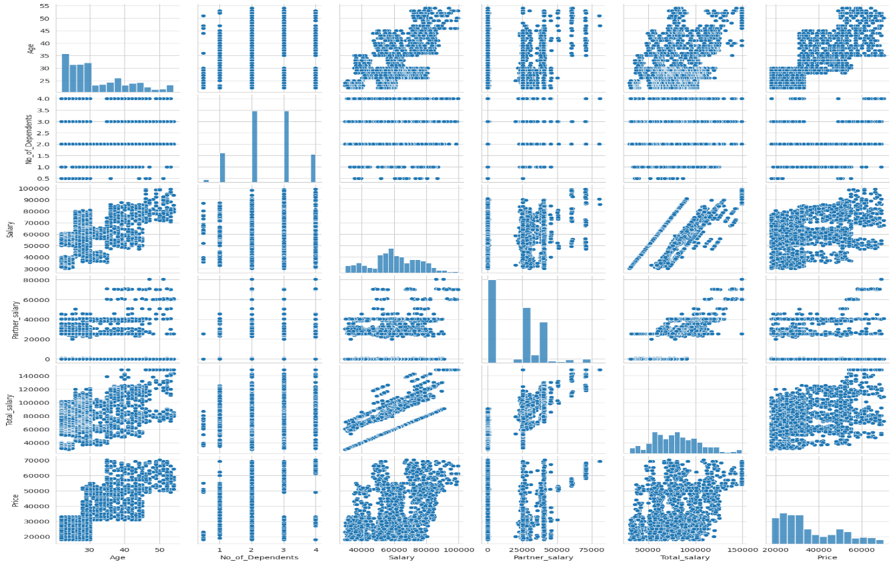
- We get multiple scatter plots showing pairwise relationships between these variables.
- Diagonal plots show univariate distributions of variables like the histograms.
- It includes scatter plots for individual variable distribution
- I used it to understand the pattern and trend of the data which is positively and diagonally moving upwards for most of the variables like Age, Salary
- Variables like no of dependents and partner salary dont show any upward diagonal trend or growth however prices No of dependents increases when compared with other variables
Analyzing the Categorical variables: Gender, Profession, Marital_status,Education, Personal_loan, House_loan, Partner_Working, make:
Using a countplot to analyse the categorical variables: Education and make
- This graph infers that the post graduate customers tend to purchase more of high-priced cars compared to graduate customers
- Most of the post graduates prefer sedan cars and then hatchback cars.
- Most of the graduates prefer sedan cars.
- If one looks at SUV sales, sale numbers are nearby same for both graduate and postgraduate customers
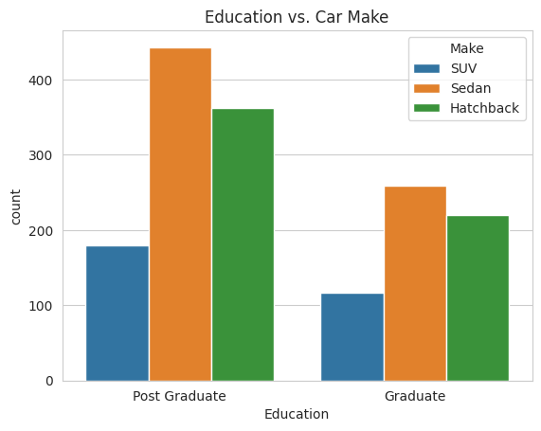
Use FacetGrid for creating multiple plots by using subsets based on 'Make' and 'Education':
- Facetgrid infers how profession varies across the make categories and education
- A graudate and salaried customers prefer more of sedan cars
- whereas graduates where they do business or job, both categories customers prefer sedan and hatchback cars equally
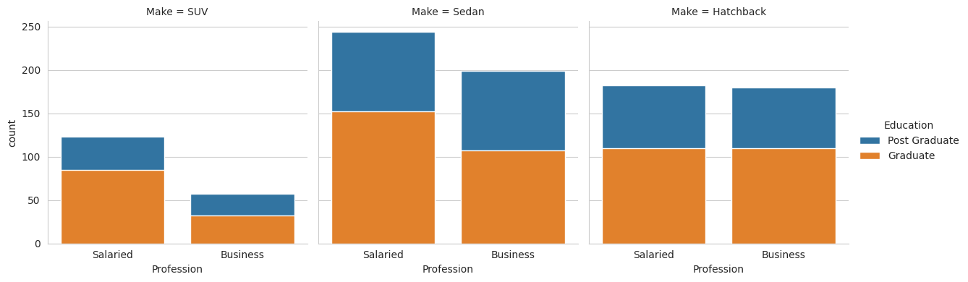

Analyzing the numerical variables and their correlation with categorical variables:
Understanding the relationship between numerical variables and Categorical variable: Price vs Salary vs Make:
- A jointplot shows the relationship between two variables price and salary thus combining scatterplot and line graph on the same graph
- The scatterplot shows a diagonal upward spread of data indicating the individuals with higher salary tend to purchase higher prices cars.
- SUV cars are purchased at higher prices and budget hatchbacks at lower price
- There are no significant outliers in the data.
- Compact clusters at mid range prices or salaries indicates that more purchases occur 30000 price and 60000 salary.
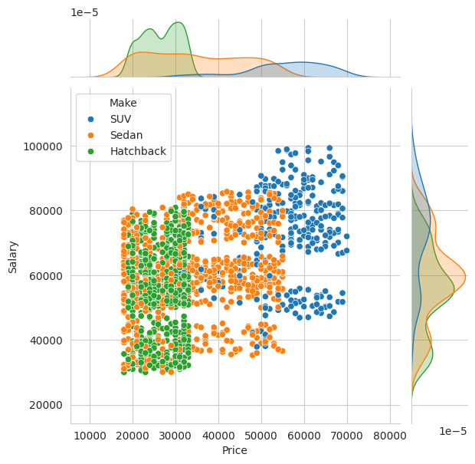
Understanding the relationship between numerical variables and Categorical variable: Make & Gender Vs Salary using a Fecetgrid
- Most of the males prefer to purchase hatchback cars whereas most of the females prefer to purchase sedan cars
- KDE density show two cluster of purchasers in sedan and hatchback models.
- A focus can be put on capturing the other low cluster datapoints and pitching the cars to these customers.
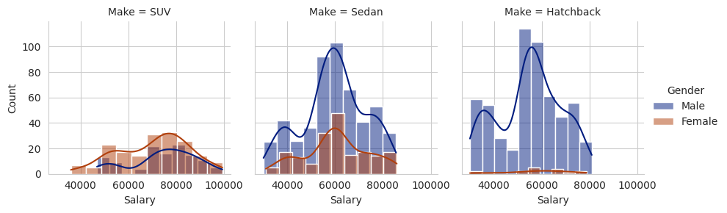
DATA QUESTIONS / RUBRIC:
- Do men tend to prefer SUVs more compared to women?
- The below graph infers that more females prefer to purchase SUV's compared to males
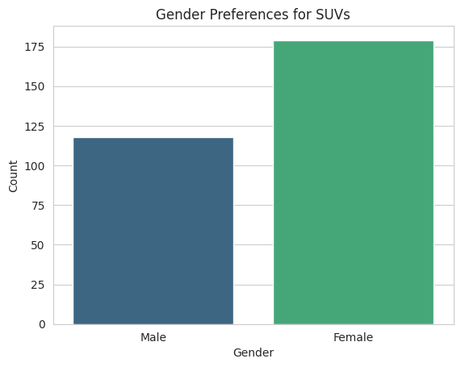
- What is the likelihood of a salaried person buying a Sedan?
- Firstly filtering the salaried person data and counting total values.
- Calculating the salaried people's likelihood of buying a sedan or a suv.
- Likelihood can be calculated by filtering sedan and suv purchases by these salaried customers and counting the total by using shape function.
- we then calculate the likelihood by proportion formula to get the below values.

The likelihood of a salaried person buying a Sedan is: 44.19642857142857
The likelihood of a salaried person buying a SUV is: 23.214285714285715

- What evidence or data supports Sheldon Cooper's claim that a salaried male is an easier target for a SUV sale over a Sedan sale?
- Filter the male salaried customers
- Create the count plot using 'Make' column
- Above graph shows that most of the males are purchasing a sedan and hatchback cars compared to SUV cars.
- However marketing team can pitch for the sale of SUV cars sale.
- But when looking at the prices for Sedan and SUV cars, it should be understood regarding the affordability of these high priced SUV cars purchase by the salaried men.
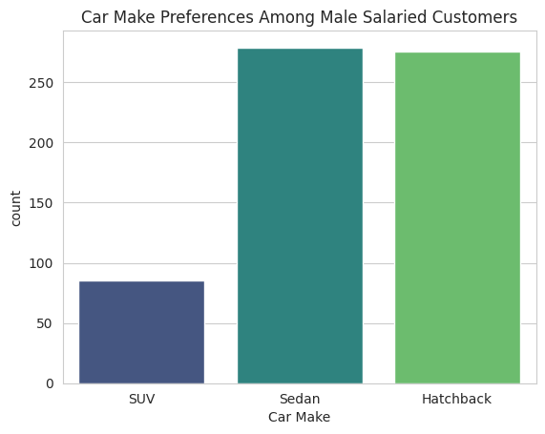
- How does the the amount spent on purchasing automobiles vary by gender?
- Creating a box plot to compare the price distribution by gender
- After observing the median values males purchase lower priced cars compared to females
- Females show a taller box indicating a higher variability in automobile prices compared to males
- Males show few outliers in purchasing higher priced cars, however treating them might disturb the data.
- Also most of the partner's salary are not captured or is zero. Hence some of the data is shown as outliers for male variable. Capturing this data by client can show better output.
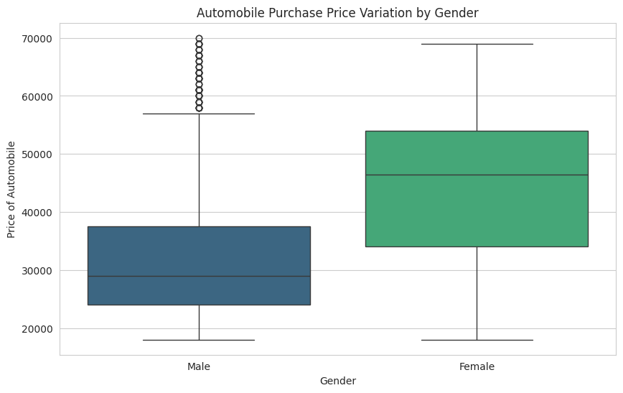
- How much money was spent on purchasing automobiles by individuals who took a personal loan?
- Filtering individuals who took a personal loan
- Calculate total amount spent on automobile purchases
- Calculate total amount spent on automobile purchases

- How does having a working partner influence the purchase of higher-priced cars?
- Filtering the higher priced cars and lower priced cars
- Further filtering the working partners from the above high priced cars data.
- Create counts for each car type
- It can be inferred that having a working partner does significantly affect the purchase of higher priced cars.
- 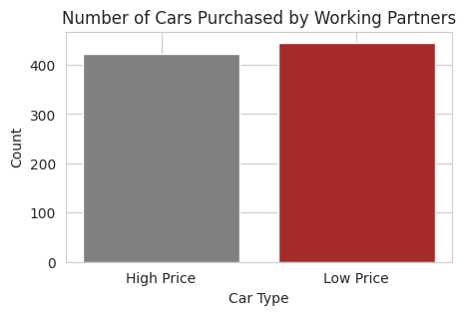

ACTIONABLE INSIGHTS AND RECOMMENDATIONS:
- Customers with versatile age group starting from 22 years to 54 years have purchased the cars.
- Nearly 50% of the customers are under age 30 which indicates that younger crowd are purchasing more compared to older age customers.
- Salaries range from 30000 to 99000 with an average salary of the customers is around 60000 whereas the average price of the car is 31000.
- Age, Partner salary and Price are heavily right skewed data with median around 30000. Which indicates most of the data is towards the lower values.
- Addressing the outliers help sort the data for better visualization and statistical analysis
- The histogram showing the plot of age of customers indicating most of the customers belong to the age group of 25-30 years.
- Most of the customers are having salaries less than median.
- The KDE plot - kernel density estimation, explains density distribution of the price having two clusters indicating the distribution of price under two ranges which is 20000 to 30000 and 45000 to 55000. Most of the customers purchased the cars at around the median price of 20000 to 30000.
- A correlation matrix of the numerical variables higher salaries seems positively correlated with purchasing higher-priced automobiles.
- Partner salary contributes significantly to Total salary with a 77% correlation.
- More dependents are leading to purchasing lower-priced cars thus explaining a negative correlation effect.
- Age has a weak correlation with automobile price, suggesting spending is not heavily age-dependent.
- Salary and total salary show strong positive correlation as total salary is the sum of salary and partner salary
- Similarly partner salary correlate well with total salary
- No of dependents and price show negative correlation which means customers having more no of dependents tend to buy lesser priced cars
- Age and price show a zero or no correlation.
- Variables like no of dependents and partner salary do not show any upward diagonal trend or growth however prices and no of dependents increases when compared with other variables.
- post graduate customers tend to purchase more of high priced cars compared to graduate customers and most of the post graduates prefer sedan cars and then hatchback cars.
If one looks at SUV sales, sale numbers are nearby same for both graduate and postgraduate customers.
- Most of the males prefer to purchase hatchback cars whereas most of the females prefer to purchase sedan cars. However while purchasing SUV’s, mostly women buy them compared to men.
- A focus can be put on capturing the other low cluster datapoints and pitching the cars to these customers.
- The likelihood of a salaried person buying a Sedan is: 44.1%
- having a working partner does significantly affect the purchase of higher priced cars

